GEMStat Data Submission Guide for Data Providers

Version 02
February 2020
UNEP GEMS/Water Data Centre

Table of Contents

General Introduction 3
Summarized Data Submission Workflow 5
Detailed Data Submission Workflow 7
1. Review of Existing Metadata 7
1.1. Screening of Registered Monitoring Locations 8
1.2. Screening of Registered Water Quality Parameters 10
1.3. Screening of Registered Analysis Methods 13
2. Registering and Updating Entities 16
2.1. Registering and Updating Monitoring Locations 19
2.2. Registering and Updating Water Quality Parameters 21
2.3. Registering and Updating Analysis Methods 23
3. Compiling a Water Quality Data Submission 27
4. Submitting Data to GEMStat 30

Document Track Changes

Version 02 | - Moved Information on reporting units from Parameter to Method Templates.  - Removed “Time Zone” and “Major Basin” columns from Station Registration Template to simplify station registration workflow..

General Introduction
Currently, the process of data submission to GEMStat is mainly handled through email communication and the exchange of files that contain the water quality data and accompanying meta-information.
The meta-information is of special importance here, since it allows for establishing a connection between individual water quality data values, the locations where the water quality samples were taken, as well as the water quality parameters themselves, together with the analysis method that was applied to them in order to get the resulting water quality values.
The accompanying meta-information should include details on the monitoring locations, water quality parameters and analytical methods, which are subject to the current submission of water quality data (if not already covered in a previous data submission). Each of these entities needs to be identified by a code. These codes are then used to unambiguously assign each individual record of the data submission to one specific monitoring location, water quality parameter and analysis method. Since these codes can be defined by the Data Providers themselves, it is possible to re-utilize codes that are already employed in their day-to-day work with water quality data.
The GEMS/Water Data Centre offers templates that define the format and sequence in which the submitted information should be provided in order to prevent ambiguity and allow for quick processing of the data. These templates are especially relevant for submitting meta-information, while the template for actual water quality data submissions is rather intended as a suggestion, since the water quality data itself can be submitted using any structured format that is most convenient for the Data Provider (including, but not limited to, CSV, Excel and XML formats).
There are three types of Excel templates provided, each dedicated to a single aspect of the data submission process, as shown in Table 1. These templates contain a number of worksheets, which can be accessed via the tabs at the bottom of the window. These tabs are colored according to their role for the submission process and the information they contain (see Table 2).
Table 1: Excel templates handed out to the Data Providers for submitting data to GEMStat.
Excel-Template | Role
1_GEMStat_Catalogue.xls | Tables with monitoring locations, parameters and analysis methods that have already been registered by the individual Data Provider in the past.  Referred to as: Catalogue
2_GEMStat_Registration.xls | Template for submitting meta-information on monitoring locations, water quality parameters and water quality analysis methods, which shall be called “entities” throughout the document.  Referred to as: Registration Template
3_GEMStat_Data_Submission.xls | Example template for submitting the actual water quality data to GEMStat.  Referred to as: Data Submission Template
Table 2: Content and Role of Excel worksheets in the templates according to the color of their tabs.
Tab-Color | Role
Grey | Accompanying information, like description of worksheets and columns, or examples.
Green | Worksheets for actual submission of meta-information for entities, or water quality data.
Blue | Inventories of entities already registered by the Data Provider within the GEMStat database.
Orange | Catalogues containing key lists or tables of all entities available within the GEMStat database.

Summarized Data Submission Workflow
In summary, the workflow for data submission consists of five steps:
- The GEMS/Water Data Centre sends the Excel templates to the Data Provider. One of the templates, the Catalogue, contains an Inventory of monitoring locations, water quality parameters and analysis methods that have been already registered by the Data Provider in the past, as well as a Parameter Catalogue that contains meta-information on all water quality parameters that are currently part of the GEMStat database.
  - If no data was submitted to GEMStat in the past, the Inventory worksheets will be empty.
- The Data Provider screens the Inventories of already registered monitoring locations, water quality parameters and analysis methods in the blue inventory worksheets of the Catalogue.
  - Check whether they are up to date and whether they already contain all the entities that will be part of the forthcoming data submission.
- If some entities of the forthcoming data submission are not listed in the Inventory worksheets (for example, a new analysis method is now in use), or if the information for some of the entities has changed (for example the quantification limits of an analysis method have changed, or a monitoring location has moved to different coordinates), this information can be entered into the green Registration worksheets of the Registration Template.
  - Each of those entities needs to be identified with a unique code.
  - We suggest using codes that are already in use at your organization (like local identification codes for monitoring locations).
  - If you have no code at hand, you can invent new codes using any combination of numbers, letters and other characters.
- The Data Provider then compiles a data submission through the Data Submission Template or any other structured format that covers the mandatory information of the template.
  - Each record of water quality data must unambiguously reference one monitoring location, one water quality parameter and one analysis method via their codes, as shown in Figure 1.
  - You can either use the codes from previously registered entities, as listed in the Catalogue, or codes of new entities that you have previously entered into the Registration Template.
Finally, the Data Provider sends the Registration Template and the file with the actual data submission (be it the Data Submission Template or any other format) to the GEMS/Water Data Centre via email (data-submission@gemstat.org) or through any other means of data exchange.

Local Parameter Code
Parameter Name
Description
Reported As
Parameter Inventory

Local Station Code
Station Name
Latitude
Longitude
Station Description
Country Code
Monitoring Type
Water Body Type
Water Body Name
…
Station
Inventory

Local Station Code
Sample Date
Sample Time
Sample Depth
Local Parameter Code
Analysis Method Code
Value
Value Flags
Integrated Sample
Remarks
Data Submission Form

Local Parameter Code
Analysis Method Code
Analysis Method Name
Methodology Description
Method Reference Version
Method Reference Number
Lower Limit Value
Lower Limit Type
Unit
Method
Inventory
Figure 1: Relationship between one entry of water quality data, with the monitoring location, water quality parameter and analysis method that it refers to.

Detailed Data Submission Workflow
Each individual data submission to GEMStat can be summarized into four general tasks, which should be processed in the listed order:
- Review of existing metadata that covers monitoring locations, water quality parameters and analytical methods (further called “entities”), which were submitted by the Data Provider in the past. If no data was submitted yet, this step can be omitted.
- Registration of new entities that are not covered by available entries of the inventories (which includes the definition of codes for them), or updating information on already registered entities.
- Compiling a submission of water quality data.
- Submitting the data and the registered entities to GEMStat (data-submission@gemstat.org).
The following sections describe these tasks in further detail and should act as a reference and a guideline, if questions regarding the individual steps arise.

Review of Existing Metadata
Initially, the Data Provider receives a pre-filled Catalogue (GEMStat_Catalogue.xls), which is individually generated for each Data Provider. It contains an Inventory of entities that have already been registered by the Data Provider at some point in the past. The entities covered by these three inventories are as follows:
- Monitoring locations with accompanying information (e.g. coordinates and name of water bodies) and their local identification codes (Worksheet Station Inventory)
- Water Quality Parameters with their description, their local identifier codes and registry numbers from the well-known CAS, ChEBI and EC registries (Worksheet Parameter Inventory)
- Analysis Methods, which were used for the analysis of water quality parameters, with their identifier codes, descriptions and lower detection limits (Worksheet Method Inventory)
Additionally, it also contains a catalogue of all water quality parameters that are known to the GEMStat database, together with their internal GEMS codes as a reference (Worksheet Parameter Catalogue).
We strongly suggest giving these Inventories a thorough screening, as described in the next three sections, in order to identify entities that can be referenced in the current data submission, or to detect entities that need to be updated with regards to their metadata (like coordinates of monitoring locations or lower limits of analysis methods). If the current data submission contains any monitoring locations or water quality parameters that are not listed in the Inventories, they should be registered with the help of the Registration Template, as described in section 2 “Registering and Updating Entities”.
If the Data Provider has not yet shared water quality data with the GEMS/Water Programme in the past, the provider-specific Inventories are empty and only the Parameter Catalogue is filled with content. In this case, the whole section for reviewing metadata can be skipped.

Screening of Registered Monitoring Locations
The worksheet Station Inventory contains all the monitoring locations, for which the Data Provider has submitted water quality data in the past.
We strongly suggest screening the Station Inventory in order to verify whether the inventory contains all monitoring locations that will be part of the current data submission and to make sure that the stored information is correct and up to date. If stations are missing or some information is outdated, the data can be added or updated with the help of the Registration Template, as described in section 2.1 “Registering and Updating Monitoring Locations”. For monitoring locations that need their information updated, you can copy the whole row, together with their GEMS Station Code, to the Station Registration worksheet of the Registration Template and change the information there.
Figure 3A shows the first ten columns of the Station Inventory worksheet, filled with example monitoring locations from Canada. Here, column B stores the Local Station Code that is used by the Data Provider for reporting water quality data. In column A, the internal GEMS Station Code is listed as a reference. All monitoring locations received by the GEMS Water Data Centre get a GEMS Station Code assigned to them, in order to uniquely identify them within the GEMStat database, even if one and the same Local Station Code is used by multiple Data Providers.
Of the remaining columns, depending on the water body type of the monitoring location (see Figure 2), only specific columns are relevant. The columns that are not applicable for a particular monitoring location are greyed out (), as can be seen in Figure 3B.
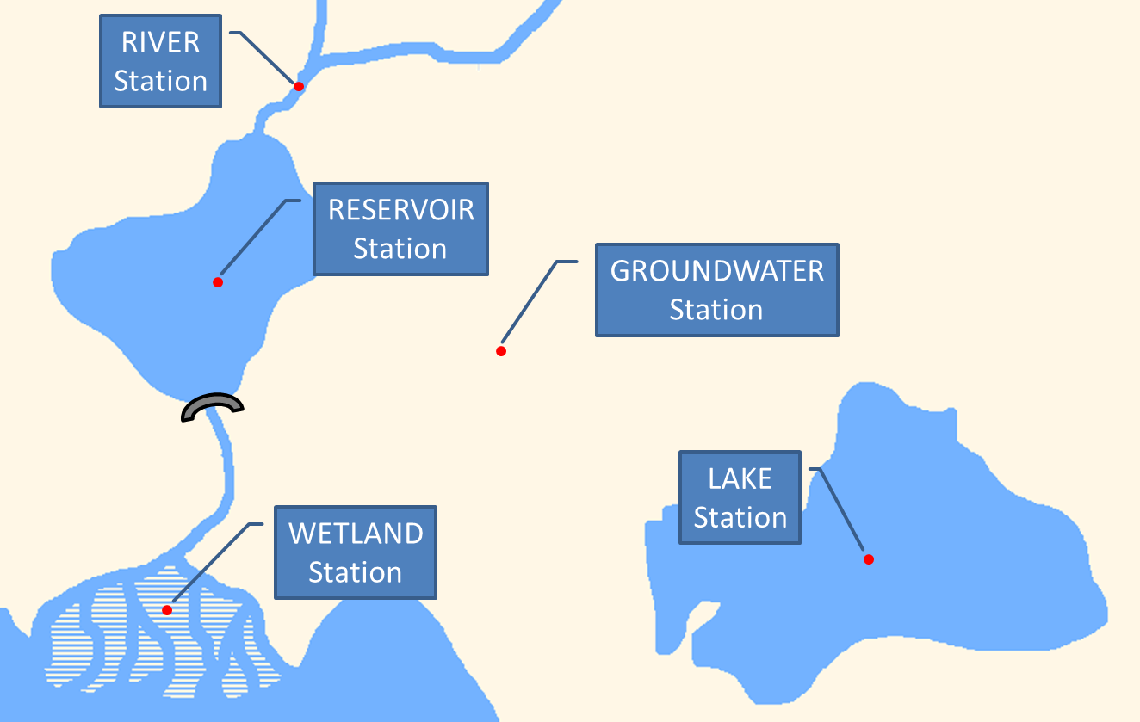
Figure 2: Water Body Types of Monitoring Locations.

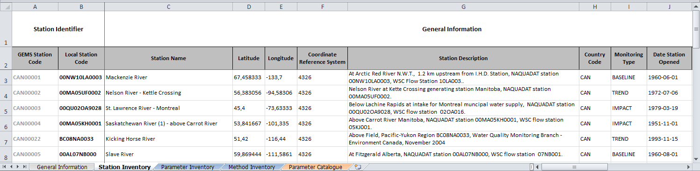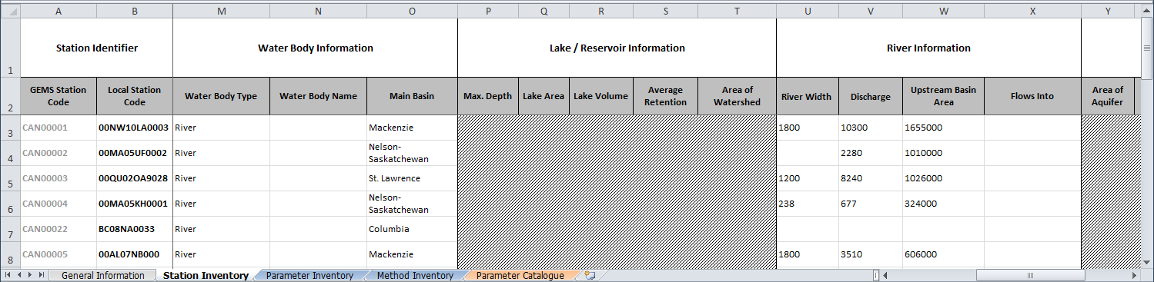
A: First ten columns of the Station Inventory worksheet covering general information on monitoring locations in Canada:
B: Further to the right of the section for general information, water body specific information can be found (columns M to AB). Columns, which are not applicable to given water body types are greyed out:
Figure 3: Example of information contained in the Station Inventory worksheet of the GEMS Catalogue for monitoring locations in Canada. A: Columns A to J containing general information on monitoring locations. B: Same table scrolled further to the right, showing the specific water body information. Columns, which are not applicable to a given water body type are greyed out.

Screening of Registered Water Quality Parameters
The Parameter Inventory contains a list of water quality parameters that the Data Provider has already registered in the past. Therefore, these parameters are “known” to the GEMStat database, meaning that there is no ambiguity on which water quality parameter inside the GEMStat database they correspond to. These known parameters make it possible for the GEMS/Water Data Centre to translate the Local Parameter Codes (as defined by the Data Provider) to the internal GEMS Parameter Codes of the GEMStat database.
You can see an example of the Parameter Inventory for Germany in Figure 4, where the Local Parameter Code is listed in column B. This Local Parameter Code can be any code that the Data Provider uses internally to identify their water quality parameters. This could be an abbreviation, the written out parameter name or even a numerical code. The corresponding GEMS Parameter Code is listed in column A as a reference.
Column C (Parameter Name) lists the parameter names according to a GEMStat internal nomenclature. This nomenclature includes the written out name of the parameter and usually the analyzed fraction (like “dissolved” or “total”). The Description in column D usually contains a description of the parameter, as stored within the GEMStat database, including a statement about the analyzed fraction. For complex organics, the Description contains the structural formula and in some cases also a selection of alternative IUPAC names.
For an unambiguous identification of the chemical parameters, the columns E to G contain their registry numbers from three widely known chemical catalogues (Chemical Abstracts Service – CAS, Chemical Entities of Biological Interest - ChEBI, European Community – EC).
The Reported as entry in column H is of special importance for the data submission process, since it shows whether the concentrations were reported in molecular form (e.g. Nitrate concentrations reported as “milligram Nitrate per liter”), or in elemental form (e.g. Nitrate reported as “milligram of Nitrogen per liter”). This information is especially vital for concentration values because concentrations reported to GEMStat will be converted to the elemental form (concentrations of “milligram Nitrate per liter” are always stored as “milligram of Nitrogen per liter” within GEMStat). Therefore, Data Providers are asked to take great care to keep the Reported as entries up to date in order to allow for an accurate conversion of reported values.
Please note: The actual reporting units of individual parameters are not listed in the Parameter Inventory, but in the Method Inventory instead. This is because in many countries the reporting units are dependent on the analysis method for the water quality parameters.
The Local Parameter Codes listed in column B of the Parameter Inventory can readily be re-used for the current data submission. You should check, however, whether these entries are still up to date and in line with the parameter codes that will be used for the actual data submission. Additionally, please also check whether the chemical form of the individual parameters in column H (Reported as) is in line with your current data submission.
If you need to register new parameters, because they are being reported for the first time, or because some details of an already registered parameter changed at your institution, you can use the Parameter Registration worksheet of the Registration Template to register this information as described in section 2.2 “Registering and Updating Water Quality Parameters”. The process of updating existing parameters is also described there.

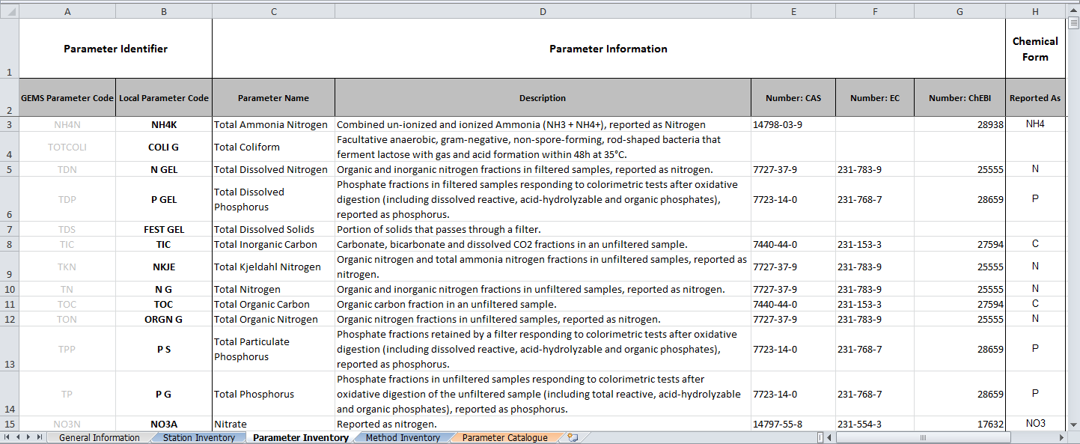
Figure 4: Example of a Parameter Inventory in the GEMStat Catalogue. Columns A and B contain the internal GEMS Parameter Code (as a reference) and the Local Parameter Code, as registered by the Data Provider for reporting water quality data. Columns C - G contain name and description of the water quality parameter, as well as the registry numbers from three well known chemical registries. The last column contains the chemical form that the parameter was reported as.

Screening of Registered Analysis Methods
The worksheet Method Inventory contains a listing of all analysis methods that were registered for each individual water quality parameter in one of the previous data submissions (see Figure 5).
Each row of this worksheet is dedicated to a single combination of a water quality parameter and an analysis method that was applied to the sample in order to obtain the reported values for one single water quality parameter, as identified by the Local Parameter Code in column A and the Parameter Name in column C. Both columns correspond to one single parameter entry in the Parameter Inventory.
The analysis method is identified by the Analysis Method Code in column B and the Analysis Method Name in column D. Both of which were chosen by the Data Provider during the registration of the method in one of the previous data submissions. As was the Methodology Description in column E, which briefly describes the steps taken during the analysis, as well as parameter specific details (such as absorbance wavelength, incubation temperature, drying temperature or similar specifics).
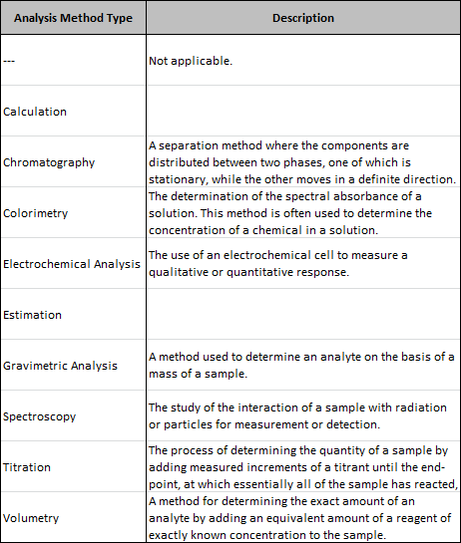
Further information on the analysis method includes the Analysis Method Type in column F and the method reference citation. The Analysis Method Type groups the registered analysis methods by type of detection used in the method (like Titration or Spectroscopy). The citation consists of the Method Reference Version in column G, listing the author and year of the method reference, and the Method Reference Number in column H, which lists the number of the method as found in the cited standard (if applicable).
The next two columns are dedicated to the limits of the method, consisting of the Lower Limit Value in column I, which is the smallest value that is reported for this method, and the Lower Limit Type in column J, identifying the lower limit either as Method Detection Limit, Limit of Quantitation or an arbitrary Reporting Limit.
The reporting Unit in column K is of special importance for the data submission process, since it defines the units of measure for water quality values that were obtained by a certain analysis method. This information is especially vital, because water quality values reported to GEMStat are converted to a common unit of measure before being stored. Therefore, Data Providers are asked to take great care to keep the reporting units up to date in order to allow for an accurate conversion of water quality values.

Please note: The units are not found in the Parameter Inventory, as you probably would have expected. Instead they are attached to each individual combination of parameters and methods in the Method Inventory. This is because in many countries the reporting units are dependent on the analysis method for the water quality parameters.
The Data Provider should carefully screen the Method Inventory for correctness of the stored information, specifically the Lower Limit Value and the Lower Limit Type in columns I and J, as well as the Unit in column K. Furthermore, the Data Provider should make sure that all parameters intended for data submission are also listed in the Method Inventory together with their respective analysis methods. New parameter / method combinations, as well as corrections to existing entries can be introduced in worksheet Method Registration of the Registration Template, as described in section 2.3 “Registering and Updating Analysis ”.

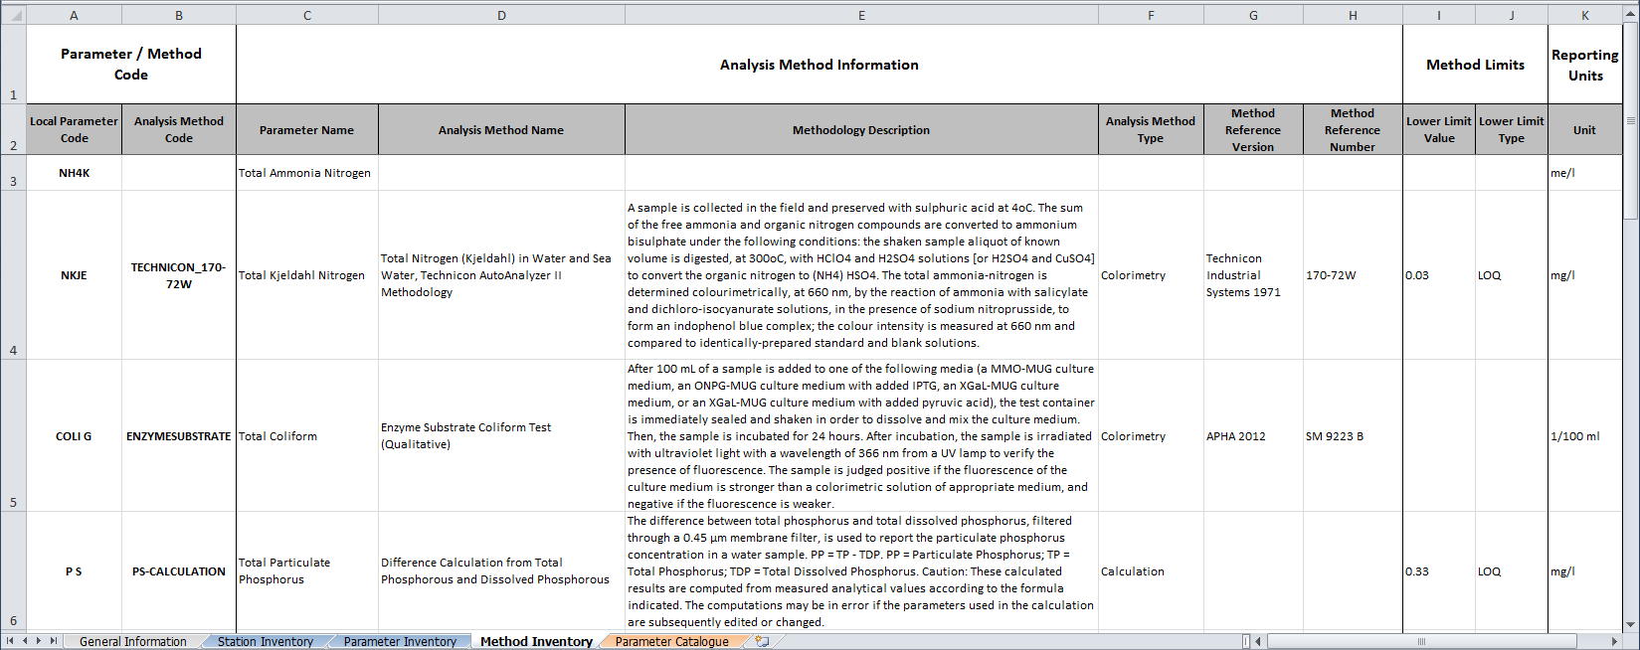
Figure 5: Exemplary Method Inventory in the GEMS Catalogue, containing the analytical methods that were used to obtain the reported water quality data for each parameter. Columns A and B contain the Parameter and Analysis Method Codes, as reported by the Data Provider, followed by parameter and method names, as well as methodology description and the analysis method type (Columns C – F). The Method Reference Version and Method Reference Number in columns G and H refer to the source that the methodologies are based on. Column I and J show the method limits and their type. Column K lists the unit that the corresponding water quality values were reported as. Please note that for water quality parameters, where no analysis method was registered, the columns with details on the method will be empty and only the reporting unit of the respective water quality parameter will be listed.

Registering and Updating Entities
When reporting water quality data to GEMStat, every reported value needs to reference exactly one single monitoring location, water quality parameter and analysis method. This creates a relation between values and entities, which puts those values into a context and allows for better informed interpretation of the water quality data.
The implication of this is, however, that each new entity for which water quality data is to be reported for the first time, needs to be registered with the GEMStat database using the Registration Template (2_GEMStat_Registration.xls) and equipped with an identification code of the Data Providers choosing before data can be reported for them.
For registering new entities, please use the following worksheets:
- Worksheet Station Registration for Monitoring Locations
- Worksheet Parameter Registration for Water Quality Parameters
- Worksheet Method Registration for Analysis Methods, specific for each reported water quality parameter
For each newly registered entity, the Data Provider is asked to define a code. This could be a code that is already in use at the Data Providers institution, e.g. for identifying monitoring locations in their monitoring network, or any other code, consisting of letters, numbers and special characters. However, each code needs to be unique in the respective domain of its entity. This means that two monitoring locations, for example, are not allowed to be identified by the same code. This, of course, also applies to the water quality parameters and analysis methods.
The rationale behind the necessity to register entities is twofold:
- To allow for an unambiguous identification of a single entity in the Data Providers domain, together with its meta-information, using one single code.
- To simplify the data submission process for the Data Provider by making it possible for them to re-use their own codes, which are potentially already in use in their own reporting schemes.
The registration of entities can be prepared simultaneously with the data submission and the codes that were assigned during the registration can directly be applied to compile a water quality data submission, as described in section 3 “Compiling a Water Quality Data Submission”.

Additionally, the Registration Template can also be used to update already registered entities with regards to the stored information. This process is comparable to the registration of new entities:
- To register new entities, fill in the information into the corresponding Registration worksheets. Columns marked with an asterisk (*) are mandatory. The other columns are optional and can be left blank, but we suggest to also providing this information, since this allows for better interpretation of the water quality values.
- To update already registered entities, proceed as follows: Copy the mandatory information from those entries of the Inventory that need to be updated into the corresponding Registration worksheets. Afterwards simply change the information of those columns, that you want to update. If the identifier code corresponds to the identifier code of the respective Inventory entry, the information in the GEMStat database will be updated accordingly by the GEMS/Water Date Centre.
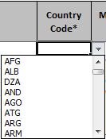
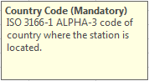
- By selecting the fields of the worksheet, you will get a hint on the kind of information that is expected, as seen in the yellow box to the right.
- Some of the columns offer a drop-down selection box from which you can choose a valid entry, like the Country Code of column H in worksheet Station Registration (see picture to the right). This measure was taken to sustain a common terminology for certain keywords.
- Entering an invalid value causes an error message to appear (Figure 6). Please refer to the Controlled Vocabularies worksheet to view a list of allowed entries for the field in question.
See Figure 7 for an overview of the components, which we have discussed above.
The codes of the entities that you enter into the Registration Template can directly be used for the data submission. Therefore, if you have registered new entities or introduced updates to some of them, please remember to include the Registration Template into the actual data submission.
If the GEMS/Water Data Centre detects new entries in the submitted Registration Template, it will update the Inventories of your individual Catalogue and provide you with an updated version that reflects the new entries or changes.
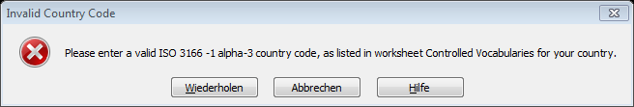
Figure 6: Error message, informing the user about the entry of an invalid value into a field. Please refer to the Controlled Vocabulary to view a list of allowed entries.

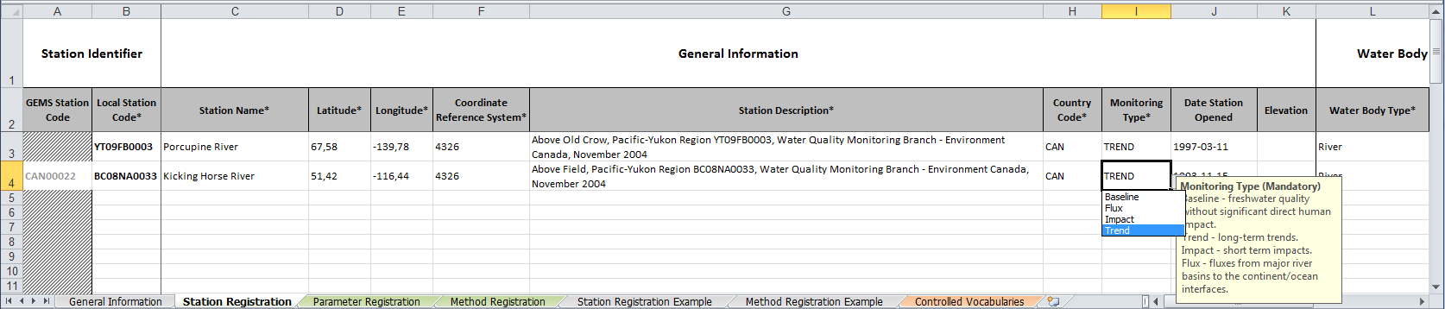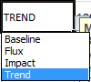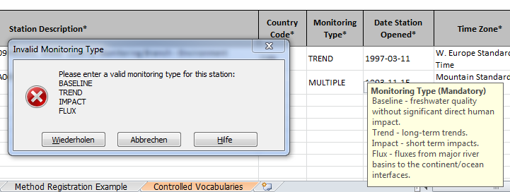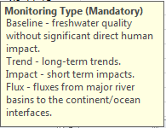
New monitoring location entered for registration (GEMS Station Code left empty).
Already registered monitoring location from the Catalogue entered into the Registration Template for updating information (GEMS Station Code provided).
Some fields are restricted to a certain set of allowed entries, which are also offered as a drop-down selection box to choose from. But they can also be filled in by hand.
If an invalid value is entered into a field that is restricted to a certain set of allowed values, an error message will appear.
Each field of the registration templates provides a pop-up description of the expected contents when selected.
Figure 7: Example of the Station Registration Template, introducing a newly registered monitoring location (highlighted in orange) and also a request to update an already registered monitoring location (highlighted in blue). Also, elements that are common to all of the registration templates, like the pop-up description (highlighted in red), the drop-down selection box (highlighted in green) and an error message, if an invalid value is entered (also in green, at the bottom of the figure) are shown.

Registering and Updating Monitoring Locations
In order to be able to view water quality data in the context of their locality, it is important to provide sufficient meta-information on monitoring locations to GEMStat. This can be done using the Station Registration worksheet of the Registration Template.
GEMS/Water is specifically interested in monitoring locations that are either designated to consistently operate for a longer period of time (3 years at the least), or were already in service for a longer time-span with a certain continuity in their operation. Therefore, it is not expected that changes and updates to the meta-information of monitoring locations are to be common. However, should it become necessary to update the information on a registered monitoring location (because the station moved to different coordinates, was taken out of service or replaced by a different station), the changes can be submitted also with the help of the Station Registration worksheet. As mentioned earlier, the process is nearly identical to the registration process, with the exception that the update of a stations meta-information requires the Data Provider to include the GEMS Station Code, which was assigned to the registered monitoring location by the GEMS/Water Data Centre and is listed in the Station Inventory, in order to avoid any confusion with other stations that are to be updated.
The process of registering or updating new monitoring locations is as follows:
- Open the Registration Template and switch to the worksheet Station Registration.
- In order to register new monitoring locations, please fill in the required information into the columns marked with an asterisk *, while leaving column A (GEMS Station Code) empty. This column is only to be filled if you intend to update metadata of already registered stations, which already have an internal GEMS Station Code assigned.
  - When entering new stations, the entries should at least provide mandatory information for the columns listed in Table 3.
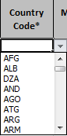
  - Make sure to provide a Local Station Code in column B, which can be any code of your choosing, but which must be unique within the Station Registration worksheet.
  - Some of the columns offer a drop-down selection box, which lists a set of values that the current field is restricted to (like the Country Code of column H in the picture to the right).
  - You will get an error notification if you have entered an invalid entry in one of those fields.
- Additional (optional) information for a new monitoring location may be provided in the remaining columns:
  - The Elevation of the monitoring location and the Water Body Name may be provided in Columns K and M.
  - Depending on the Water Body Type in column L, additional information for the water body specific properties may be provided in the following columns (columns that are not applicable for a given water body type will be greyed out):
    - Lake / Reservoir: Columns N to R
    - River: Columns S to U
    - Groundwater: Columns V to Z
- If you wish to update information on monitoring locations listed in worksheet Station Inventory of the Catalogue, please proceed as follows:
  - Copy the complete entry that needs updating from the Station Inventory to the Station Registration worksheet.
    - Please make sure that the copied entry includes the GEMS Station Code in column A
  - Change the information of the individual columns as you desire.
    - Please leave the entries of column A (GEMS Station Code) unchanged. This information is essential for the GEMS/Water Data Centre to attribute the updated information to the correct monitoring location internally.
- Save the Registration Template to permanently store the information that you have entered.
- You can now use the Local Station Code that you have entered in column B to report water quality data for newly registered monitoring locations using the Data Submission Template.

Table 3: Description of mandatory columns for the registration of new stations with the GEMStat database.
Column | Field Name | Requirements
B | Local Station Code | Monitoring location identifier, as used by the Data Provider in their monitoring network.
 |  | Format: Any combination of letters and numbers.
C | Station Name | Sufficiently descriptive name of monitoring location.
Format: Water body name - "at" Location specifier
e.g. Aare River –at Brugg
D | Latitude | Cartesian y-Coordinates in given Coordinate Reference System (see column F).
 |  | e.g. 47.4839
E | Longitude | Cartesian x-Coordinates in given Coordinate Reference System (see column F).
 |  | e.g. 8.1958
F | Coordinate Reference System | Coordinate-based reference system for Latitude and Longitude coordinates.
Value: EPSG code of reference system (from www.epsg-registry.org).
e.g. 4326 for WGS84
G | Station Description | Short description of monitoring location and special conditions.
 |  | e.g. Measuring station lies before the confluence of the Aare with the Limmat and the Reuss rivers.
H | Country Code | ISO 3166-1 ALPHA-3 code of country, where the station is located in.
Value: Insert entry from column B in worksheet "Controlled Vocabularies".
e.g. CHE for Switzerland
I | Monitoring Type | Type of monitoring activity.
 |  | Value: Baseline, Trend, Impact or Flux
J | Date Station Opened | Date when monitoring location was established.
Format (ISO 8601): YYYY-MM-DD
e.g. 1978-01-01
L | Water Body Type | Type of water body, at which the station is located.
 |  | Value: Lake, Reservoir, Wetland, River or Groundwater

Registering and Updating Water Quality Parameters
By registering water quality parameters with the GEMStat database, you allow the GEMS/Water Data Centre to translate your own identification codes of water quality parameters to the internal ones used within the GEMStat database. This makes it possible for you to keep on using your own parameter identifiers, which are already in place at your institution, without the need to adapt to the naming conventions of the GEMStat database. The only requirement is that you register the water quality parameters with the help of the Parameter Registration worksheet, particularly whenever a new parameter is added to the data submission, or when there were changes to any of the already registered parameters.
If any changes with regard to water quality parameters occur at your institution (like a change of the parameter code for an already registered parameter or in the chemical form that the parameter is reported as – e.g. Nitrate reported in molecular form as “mg Nitrate per litre” or in elemental form as “mg Nitrogen per litre”), this can also be accounted for by updating the information of the affected parameter with the help of the Parameter Registration worksheet. The GEMS/Water Data Centre will then take the reported changes into account.
To register or update a water quality parameter, please proceed as follows:
- Open the Registration Template and switch to the worksheet Parameter Registration.
- For each parameter that you want to register, provide a Local Parameter Code in column A.
  - This may be any combination of letters, numbers and punctuation characters that unambiguously discerns the parameter from the other parameters.
  - If you provide a Local Parameter Code that is already listed in the Parameter Inventory, the information for the parameter with the same Local Parameter Code will be updated accordingly.
- Specify the Analysed Fraction of the parameter in column B.
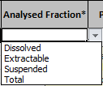
  - The analysed fraction mostly refers to the filtration status of the sample, but can also includes the pre-treatment form of “extraction” for metals.
  - The available options can be selected from a drop-down selection box (see picture on the right). Please refer to Table 4 for a description of the analysed fractions.
- To make it possible for the GEMS/Water Data Centre to correctly interpret and identify the water quality parameter, please provide a Parameter Reference in column C.
  - This could be a registry number from one of the well-known chemical registries (CAS, ChEBI or EC).
  - Alternatively, you can also provide the full name of the parameter.
Table 4: Description of analysed fractions.
Fraction | Description
Dissolved | Analyte fraction that passed through a 0.45 µm membrane filter.
Extractable | Analyte fraction in solution after treatment of an unfiltered sample with hot dilute mineral acid.
Suspended | Analyte fraction that are retained by a 0.45 µm membrane filter.
Total | Analyte fraction of an unfiltered sample.
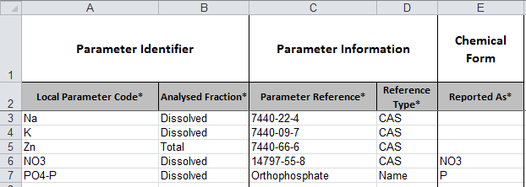
Parameter Reference provided as a CAS Registry Number, which allows for an unambiguous identification of the parameters with the help of the CAS catalogue
Nitrate concentrations reported in molecular form “as Nitrate”.
Orthophosphate concentrations reported in elemental form “as Phorphorus“
Parameter codes, as chosen by the Data Provider
One of the parameters was referenced with the help of the full parameter name.
Figure 8: Example of registering water quality parameters with the help of the Parameter Registration worksheet.
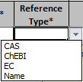
- To avoid incorrect interpretations and to allow for an automated processing of the parameter registration, please set the Reference Type in column D.
  - The available options can be selected from a drop-down selection box (see picture on the right).
  - This makes it possible to unambiguously understand the type of Parameter Reference that you provided in column C.
- Define the chemical form for the reported concentrations of the water quality parameter in the Reported As field of column E.
  - This important information clarifies whether concentrations of a parameter like “Nitrate” are reported in the molecular form as “mass of Nitrate per liter”, or in the elemental form as “mass of Nitrogen per liter”.
  - Enter the molecule (e.g. Nitrate) or element (e.g. Nitrogen) that the parameter is reported as into this field.
- Save the Registration Template to permanently store the information that you have entered.
- You can now use the Local Parameter Code that you have entered in column A to report water quality data for newly registered water quality parameters using the Data Submission Template.

Registering and Updating Analysis Methods
The registration of analysis methods with the GEMStat database is an essential part of the data submission process, since this step ensures whether the water quality data will retain its context and significance even after long periods of time.
In principle, each of the water quality parameters, for which data is shared, is required to have at least one accompanying analysis method entry (even if the actual details, like Analysis Method Code and Analysis Method Name are left empty), together with the reporting Unit for this particular parameter / method combination. Sometimes, it could even be necessary to register more than one methodology for a given parameter, for instance if some of the laboratories use different methods to analyze their samples with regards to a certain parameter, or if the methodology changed in the timeframe of the reported data.
The workflow below describes the process of methodology registration in further detail. As with the other entities, the information of an already registered method can be updated by registering it anew with the same Analysis Method Code, while introducing the desired changes to the columns that need their information updated (like the Lower Limit Value or the Unit).
- Open the Registration Template and switch to the worksheet Method Registration.
- Enter the Local Parameter Code of the water quality parameter, for which you want to register or update an analysis method into column A.
  - This can be the code of a newly registered parameter from the Parameter Registration worksheet,
  - or the code of a previously registered parameter from the Parameter Inventory worksheet in the Catalogue.
- Enter an Analysis Method Code of your choosing in column B for the current analysis method. You will later need the Local Parameter Code and the Analysis Method Code together for the reporting of water quality values.
  - We suggest using a code that is already in use at your institution for annotating analysis methods, like the number of the standard methodology (e.g. ISO 7150-1) or any other combination of characters and numbers.
  - Please keep in mind that while a given Analysis Method Code uniquely identifies a given analysis method, this method can potentially be used to analyze a sample for a number of different parameters (for example the inductively coupled plasma method can be utilized to analyse a sample for multiple metals like Zinc and Chromium, at different emission wavelengths). So, in principle, one and the same Analysis Method Code can be registered for multiple parameters.
  - If no information on the analysis method is available to you, the Analysis Method Code may be left empty.
- Provide an Analysis Method Name of your choosing in column C.
  - If no information on the analysis method is available to you, the Analysis Method Name may be left empty.
- Provide a short Analysis Method Description in column D (if available) according to a Standard Method, the Standard Operating Procedures (SOPs) of your laboratory or other references.
  - The description of the analysis method should be specific for the water quality parameter that is being analyzed, when possible.
  - If for example, you register a method based on inductively coupled plasma for multiple metal parameters, the Analysis Method Code and Analysis Method Name would stay the same for each of the different metal parameters. The description, however, should take into account the different analytical wavelengths that were used for the individual parameters.
- If the registered method can be traced to a published standard or methodology, please provide the author or organization that published the method, and the year of publication as the Method Reference Version in column E.
  - A method from the 22nd Edition of “Standard Methods for the Examination of Water and Wastewater” from the American Public Health Association could be cited here as “APHA 2012”
  - A method from the International Organization for Standardization, published in 2007 could be cited as “ISO 2007”
- If the cited method is identified by a reference number in the above mentioned publication, please provide it as the Method Reference Number in column F.
  - APHA 2012 identifies the inductively coupled plasma mass spectrometry method as “SM 3120 B”
  - ISO 2016 identifies the inductively coupled plasma method for water quality analysis as “ISO 11885:2007”
- If available, provide the reporting limits of the method for the current parameter as the Lower Limit Value in column G.
- Select the Lower Limit Type in column H.
  - A drop-down selection box offers three types of lower limits to choose from (see Table 5).
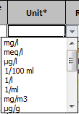
- In any case, provide the Unit of the reported analysis results for the current parameter / method combination in column I, even if no information on the analysis method was available.
  - The available options can be selected from a drop-down selection box (see picture on the right), and can be extended upon request.
  - This allows the GEMS/Water Data Centre to correctly convert the submitted water quality data for each individual parameter and method combination to a common unit internally.
- Save the Registration Template to permanently store the information that you have entered.
- You can now use the Analysis Method Codes from column B together with the Local Parameter Codes of their respective water quality parameters to report water quality data as described in section 3 “Compiling a Water Quality Data Submission”.

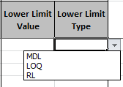
Table 5: Different types of lower limits.
Lower limit type | Description
MDL | Method Detection Limit  Lowest concentration up to which the presence of a compound can be detected with sufficient confidence.
LOQ | Limit of Quantitation  Lowest concentration where a compound can not only be reliably detected but also some predefined goals for bias and imprecision are met.
RL | Reporting Limit  Limit set by the Laboratory using other criteria than stated above. Usually higher than Limit of Quantitation.

As you can see in Figure 5, it is possible to individually combine parameters and analysis methods. So you can have two different analysis methods for Dissolved Mercury, for example, as listed in the first two rows of the worksheet. Both parameter / method combinations could actually have different reporting units. Conversely, you can combine multiple parameters with the same analysis method, as seen in the last three rows of the worksheet: All three dissolved metal parameters were analyzed using a Inductively Coupled Plasma – Atomic Emission Spectroscopy method, based on the same Method Reference (column E and F), but with slightly different Methodology Descriptions.
It should be stressed that each newly registered water quality parameter should have a corresponding entry in the Method Registration worksheet, even if no details on the analysis method are available to you. Specifically because the information on the reporting Unit for the particular water quality parameters are necessarily to be provided for individual parameter / method combinations (even if the details on the actual method may be potentially left empty).

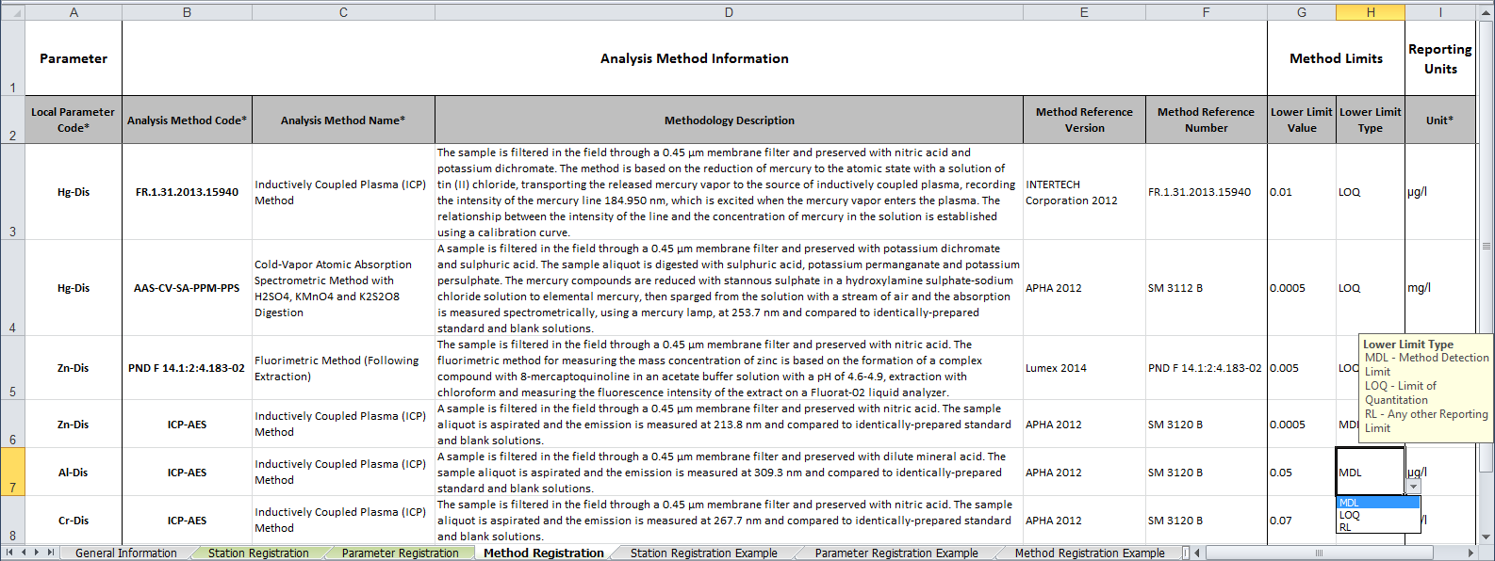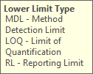
Two different analysis methods registered for the same parameter (Dissolved Mercury).
Same analysis method (ICP-AES) with different specifics regarding the Analysis Methodology Description registered for three different water quality parameters.
Pop-up description of expected entries for the Lower Limit Type.
Drop-down selection box showing the permitted entries for the Lower Limit Type.
Figure 9: Example of registering analysis methods with the help of the Method Registration worksheet. Here, the data on Dissolved Mercury was produced by two different methods, each having different reporting units. On the other hand, the data on three different dissolved metal parameters were produced by the same method (ICP-AES) with different detection wavelengths.

Compiling a Water Quality Data Submission
Data submissions can be compiled in two ways:
- Using the Data Submission Form worksheet of the Data Submission Template (3_GEMStat_Data Submission.xls):
  - This template offers a pre-defined column structure that covers all the mandatory information for a data submission in one Excel worksheet.
  - On the other hand, however, this template is prone to the limitations of Excel, and thus only allows for the maximum number of 65,536 rows per worksheet.
- Using any other structured format that is in use at your institution for data sharing (e.g. CSV files, database extracts and others):
  - This allows you to use your own tools and workflows to compile the data submission.
  - However, the minimum requirement is that you provide the mandatory information of Local Station Code, Sample Date, Sample Time, Sample Depth, Local Parameter Code, Analysis Method Code and reported Value.
  - The GEMS/Water Data Centre can adapt to variations in naming and in order of the columns, so you can stick to the structure that you are used to.
In both cases it is crucial, that each value entry is related to a sampling location, a water quality parameter and an analytical method via the Local Station Code, the Local Parameter Code and the Analysis Method Code, as shown in Figure 10. So the value entries will either reference an entity that you have already registered in the past, as stored in the newest version of your Catalogue, or a newly registered entity, which you have entered into the Registration Template prior to compiling the data submission.
The water quality values should be submitted in a parameter oriented format. This means that each water quality entry should be entered in a new row and identified individually with regards to the sampling location, the date and time of sampling, the depth from which the sample was taken, the water quality parameter and analysis method. This implies that two water quality values resulting from a sample that was taken at the same location and at the same date, time and depth, but belonging to two different water quality parameters, should be placed in two different rows.
When using the Data Submission Template, the workflow for compiling a data submission is as follows:
- Column A requires the Local Station Code of the location, where the sample was taken.
  - This code must reference an already registered sampling location, either in the Station Inventory of the Catalogue, or a newly registered location from the Station Registration worksheet of the Registration Template.
- Enter the date, when the sample was taken into column B (Sample Date).
  - We suggest using the ISO 8601 format for the dates, consisting of four digits the year, followed by two digits for month and two digits for day, each separated by a hyphen (YYYY-MM-DD).
  - But in principle, any numeric date format is acceptable, as long as it is consistent throughout the data submission.
- Enter the time of sampling into column C (Sample Time).
  - We suggest using the ISO 8601 format for the time, with two digits for hours and two digits for minutes, separated by a colon and using the 24 hours format.
  - This information is optional and defaults to “00:00” if left empty.
- Enter the depth (in meters) from which the sample was taken into column D (Sample Depth).
- Enter the Local Parameter Code of the parameter, which is represented by the current water quality value into column E.
  - This code must reference an already registered water quality parameter, either in the Parameter Inventory of the Catalogue, or a newly registered location from the Parameter Registration worksheet of the Registration Template.
- Enter the Analysis Method Code of the analytical method that was used to analyze the sample with regards to the current water quality parameter into column F.
  - This code must reference an already registered analytical method, either in the Method Inventory of the Catalogue, or a newly registered analytical method from the Method Registration worksheet of the Registration Template.
- Enter the reported Value into column G.
  - Please enter only numerical values in this column. If any Flags (like “<”) are present, separate them from the value and place them into the next column.
- Any Value Flags that are part of the reported value are to be entered into column H.
  - This includes flags, which identify the value to be lower than the detection limit or indicate contamination of the sample.
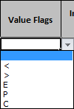
  - The range of allowed values are restricted to the following entries, which can be chosen from a drop-down selection box:
< | Less than Detection Limit or Lower Quantitation Limit
> | Greater than Upper Quantitation Limit
E | Estimate (but was measured)
P | Most probable value
C | Contamination detected

- If the reported value is the result of an Integrated Sample, please identify the type of sample integration in column I.
  - Currently three types of sample integration are recognized:
V | Vertical Integration: Mix of multiple samples from evenly distributed depths.
H | Horizontal Integration: Mix of multiple samples, evenly distributed along a horizontal transect.
T[x] | Time Integration: A sample consisting of small subsamples, taken over a period of [x] days. An integrated sample over 7 days would thus be identified as “T7”.

- Any remarks that are concerned with the reported value can be entered into column J (Remarks).

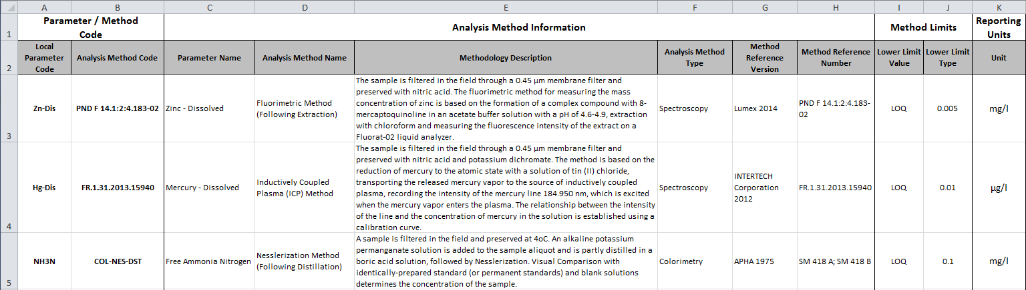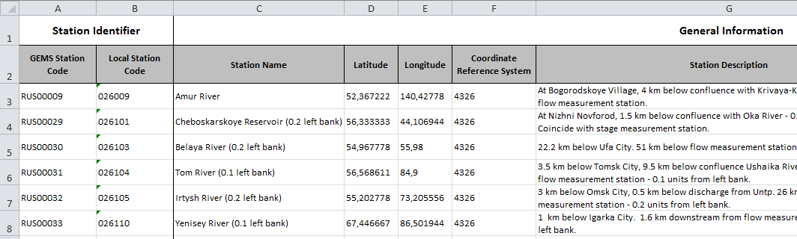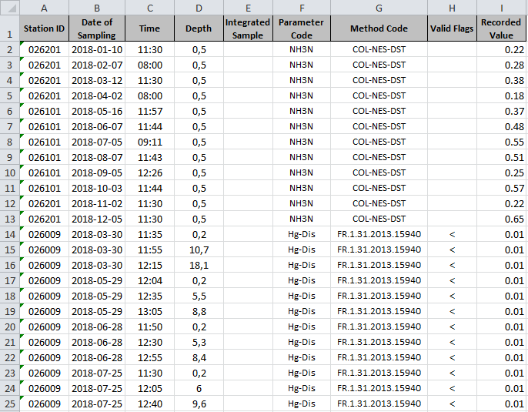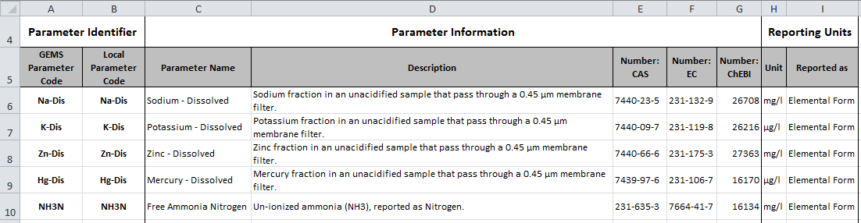
Water Quality Data
Analysis Methods
Monitoring Locations
Parameter
Figure 10: Relationship between the entries of a data submission table and the corresponding monitoring locations, water quality parameters and analysis methods in the Catalogue.

Submitting Data to GEMStat
The official submission process for GEMStat is currently based on data transfer via email to data-submission@gemstat.org. While it is also possible for you to share the data using an FTP or cloud services, we currently do not have such facilities at hand ourselves. Thus we cannot offer upload or push functionalities at the moment. Therefore, if the size of the data submission would prevent you from submitting it via email, we need to ask you to upload the data submission into an online storage of your choosing and notify us via email, so that we can pull the data from the storage in a timely manner.
Depending on whether or not you have registered new entities for the current data submission the following files should be included:
- The actual water quality data, consisting either of the Data Submission Template or of files of other format, compiled according to the guidelines in section 3.
- The Registration Template, if new entities have been registered or updated for the current data submission, according to the guidelines in section 2.
Since GEMS/Water strives to account for the individual data sharing policies of the participating countries and organizations, you should also make a statement regarding the terms, on which the submitted data may or may not be shared with third parties. GEMS/Water offers three data policy options to choose from, which are described in Table 6 below.
After receiving the data submission, the GEMS/Water Data Centre will first check, whether it contains a Registration Template. If so, it will proceed to screen its entries and determine whether those are newly registered entities or updates for already registered ones. Following this, the entities will be imported into the GEMStat database, while the local codes of the entities will be translated to the GEMStat internal codes for monitoring locations, parameters and methods.
Subsequently the data submission file will be automatically parsed, using your codes to map the water quality values to their respective entities. During this process, quality checks are applied in order to assess the plausibility and consistency of the values. Values that fail these checks are separated from the data submission for further processing, while the remaining values are imported into the GEMStat database.
Upon finalization of this process, you will get a notification regarding the amount of imported data and, if applicable, the problems that were encountered during the quality checks. If new entities were registered, you will get an updated Catalogue that reflects these changes for further reference.
Table 6: The three Data Policy options of GEMS/Water.
Available Data Policy Options | Description
OPEN | Raw water quality data is publicly available and can be requested by everyone.
LIMITED | Raw water quality data is shared on written request for non-commercial research only. For every other purpose, only metadata and yearly aggregates on country level can be requested.
RESTRICTED | Raw data is not shared and its use by GEMS/Water is limited to UN-assessments and aggregated data products.

